**Project Design Phase-II**

**Data Flow Diagram & User Stories**

| Date | June 2025 |
| --- | --- |
| Team ID | LTVIP2025TMID33933 |
| Project Name | EduTutor AI |
| Maximum Marks | 4 Marks |

**Simplified Flow Graph**

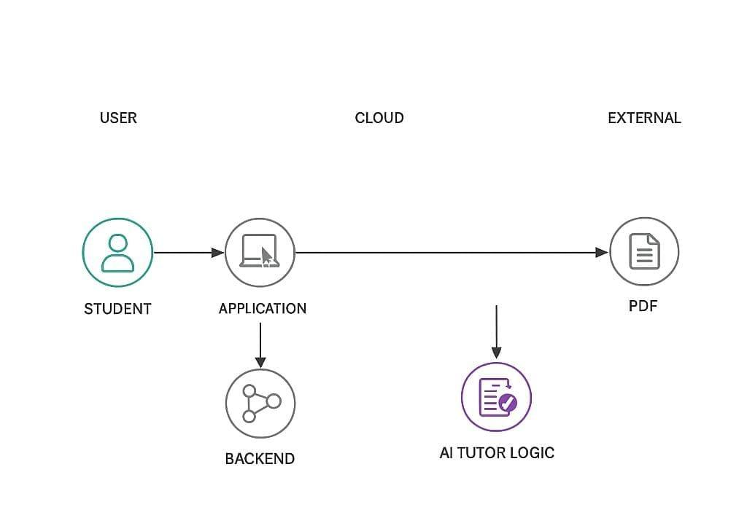

1. Student logs in and asks a question.

2. Question is submitted to the backend service

3. Retrieval-augmented generation (RAG) fetches related content

4. AI tutor logic generates a quiz and exports a PDF file

5. The PDF quiz is provided to the student

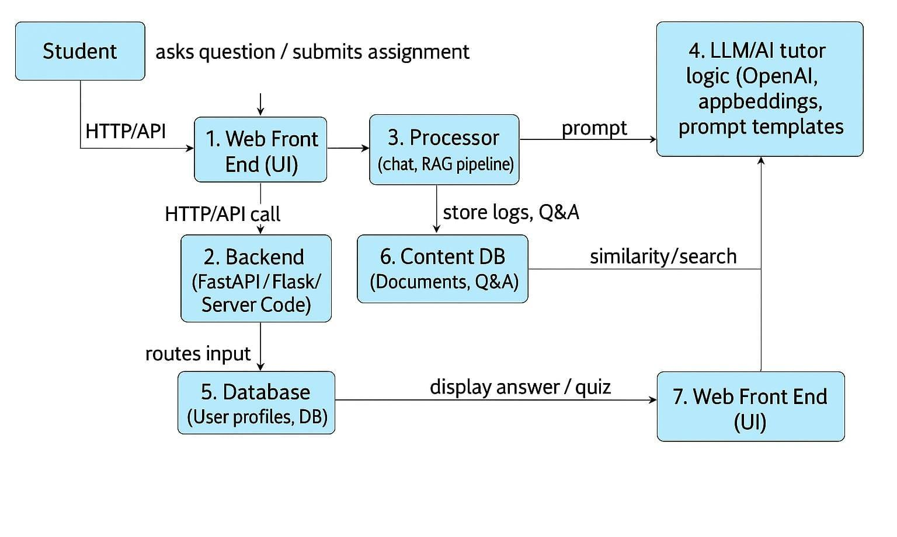

User Stories for Edu Tutor AI

| User Type | Functional Requirement (Epic) | User Story Number | User Story / Task | Acceptance Criteria | Priority & Release |
| --- | --- | --- | --- | --- | --- |
| Customer (Mobile user) | Registration | USN-1 | As a user, I can register for the application by entering my email, password, and confirming my password. | I can access my account / dashboard | High / Sprint-1 |
|  |  | USN-2 | As a user, I will receive confirmation email once I have registered for the application. | I can receive confirmation email & click confirm | High / Sprint-1 |
|  |  | USN-3 | As a user, I can register for the application through Facebook. | I can register & access dashboard with Facebook login | Low / Sprint-2 |
|  |  | USN-4 | As a user, I can register for the application through Gmail. | I can register & access dashboard with Gmail login | Medium / Sprint-1 |
|  | Login | USN-5 | As a user, I can log into the application by entering email & password. | I can access the dashboard after login | High / Sprint-1 |
|  | Dashboard | USN-6 | As a user, I can view my AI-generated lessons, quizzes, and performance report. | I can see my learning progress and available tasks | High / Sprint-2 |
| Customer (Web user) | Lesson Interaction | USN-7 | As a user, I can ask questions or request quizzes using the web interface. | I get a real-time response from the AI tutor | High / Sprint-1 |
|  | Lesson Management | USN-8 | As a user, I can access saved lessons and past quiz history. | I can view/download previous AI interactions | Medium / Sprint-2 |
|  | Profile Management | USN-9 | As a user, I can update my profile, learning preferences, and subject interests. | Profile info is updated and reflected immediately | Low / Sprint-2 |
| Customer Care Executive | User Support | USN-10 | As a support executive, I can view customer issues or feedback from the dashboard. | I can respond to and resolve tickets submitted by users | Medium / Sprint-3 |
|  | Issue Tracking | USN-11 | As a support executive, I can escalate unresolved technical issues. | Issues get tagged and notified to the admin | Low / Sprint-3 |
| Administrator | User Management | USN-12 | As an admin, I can view, suspend, or delete users from the platform. | User changes take effect immediately | High / Sprint-3 |
|  | System Monitoring | USN-13 | As an admin, I can monitor system usage and performance metrics. | I can view active sessions, system load, and logs | High / Sprint-3 |
|  | Content Oversight | USN-14 | As an admin, I can review AI-generated content for quality. | I can approve or flag content for revision | Medium / Sprint-4 |